**Student Name: Basavraj Nagappa Jaliminche**

**Student Id: 8800149**

**PROGRAM: Reporting Systems and Database Development (1517)**

**Course Name: IT Project Management MGMT8770**

**Assignment No: 01**

**Assignment No: 01**

Q.1 Project Management:

Project management is the use of some knowledge, skills, tools and techniques to project activities to meet project requirements.

Project management framework:

A project management framework is a set of processes, tasks and tools that provide guidance and structure for the execution of a project. Key elements of project management framework includes

* Project Stakeholders
* Project management knowledge areas
* Project management tools and techniques
* Project success

Project Stakeholders:

Stakeholders are the people who are involved in project activities

For example, consider we have to develop a software so stakeholders can be like

1. The project sponsors can be the customers who want to buy the software.
2. The software can be developed by financing by a financial institution.
3. The project manager will be responsible for the developing the project.
4. The developers and testing team are developing the software.
5. Competitors such as different companies who want to build the same kind of software.

Project Management Knowledge Areas:

It describes key competencies of the project

1. Project Scope management is the defining and managing the whole project to complete successfully.
2. Project schedule management includes estimation of time, preparing schedule for completion of project.
3. Project cost management includes the creating the budget for the project.
4. Project quality management ensures the quality of the project.
5. Project resource management consist of managing the resources of the project.
6. Project communication management includes the generation the storing the project information.
7. Project risk management includes calculating and solving the risk related to the project.
8. Project procurement management includes the procuring the required services form the supplier.
9. Project stakeholder management includes the communication to the stakeholders to satisfy their needs.
10. Project integration management is the coordination of all elements of a project.

Project management tools and techniques:

Project management tools and techniques assist project managers and their teams in carrying out work in all 10 knowledge areas.

1.Integration Management: In this techniques are Project selection methods, Project management methodologies, Stakeholder analyses, Work requests Project charters, Project management plans, Change control boards, Project review meetings and we do it by project management software.

2. Scope management:

In this techniques are Statements of work, Scope management plans, Scope verification techniques, Scope change controls also by Work breakdown structure.

3. Schedule management:

In this techniques are Project network diagrams, Critical path analysis, Crashing Fast tracking, Schedule performance measurements. We can achieve it by creating the Gantt charts.

4. Cost management:

In this techniques are Project budgets, Net present value, Return on investment, Payback Analysis, Earned value management, Project portfolio management, Cost Estimates, Cost management plans, Cost baselines.

5.Quality management

In this techniques are Quality Metrics, Checklists, Quality control charts, Pareto diagrams, Fishbone diagrams, Maturity Models, Statistical methods, Test plans.

6.Resource management:

In this techniques are Motivation techniques, Empathic Listening, Responsibility assignment matrices, Project organizational charts, Resource Histograms, Team building exercises.

7.Communications management:

In this techniques are Communications management plans, Conflict Management, Communications media selection, Status reports, Virtual Communications, Templates Project websites

8. Risk management:

In this techniques are Risk management plans, Risk Registers, Probability/impact matrices

9. Procurement management:

In this techniques are Make-or-buy analyses, Contracts Requests for proposals or quotes, Source selections, Supplier evaluation matrices.

Now a day, if you want to make sure every project deliverable comes out phenomenally, you should consider using Scrum, one of the most popular Agile methodology techniques.

Project Success:

The project success refers to terms of

1. The project met scope, time, and cost goals.
2. The project satisfied the customer
3. The results of the project met its main objective, such as making or saving a certain amount of money, providing a good return on investment, or simply making the sponsors happy.

Q.2 Answer:

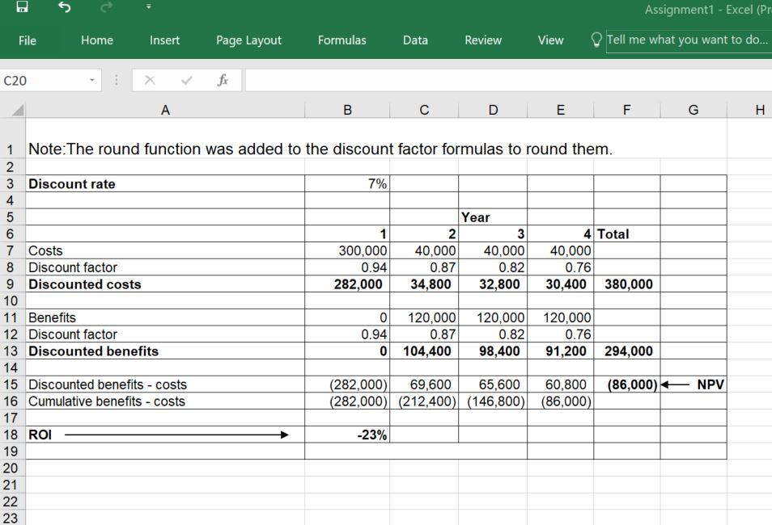

1.Return on investment is negative. So we didn’t get positive return on our investment

2.NPV value is also negative.

3.We didn’t get payback still in 4th year.

Conclusion: Based on my financial analysis I would not like to invest in this project.